1. Perform wordcount operation in local mode. Share the code, explain the execution steps, and attach the output screenshot.

Here in the local mode we do have to write a java code of mapreduce in the eclipse and import all the jars required from the Hadoop common and yarn as well as the jars for mapreduce. Here I have used word count program of the map only job of word count.

To run in the local mode we need to set the project and the main class as well as we need to set the arguments in the argument tab as shown in the screen shots. The arguments set are needed by the job to be executed.

Driver:

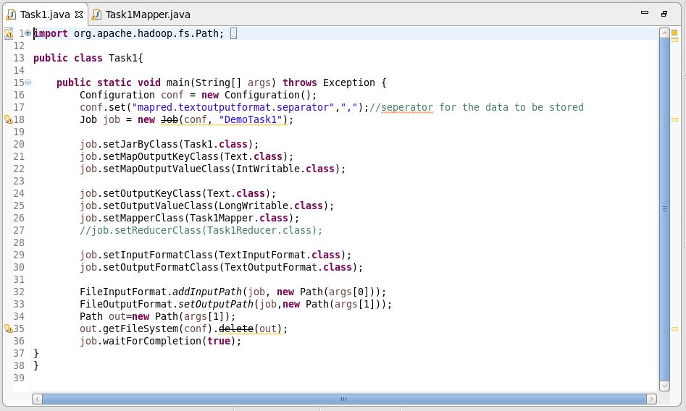

Mapper:

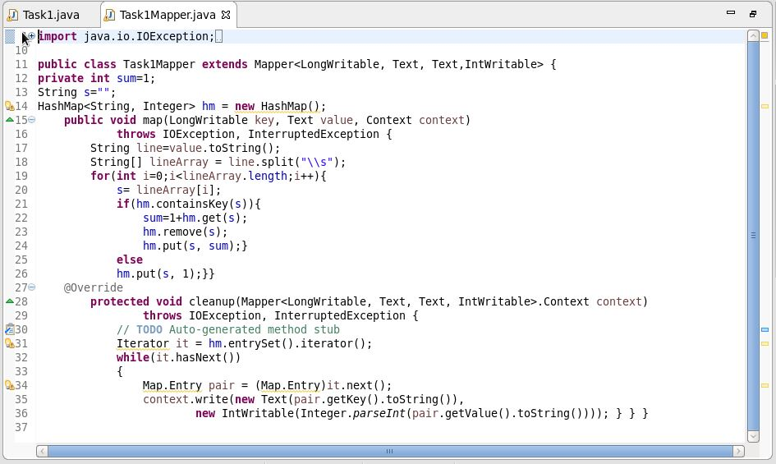

The mapper class is the map only class. Which is used to run the word count without reducer. For that we have to implement the cleanup method.

Configuration:

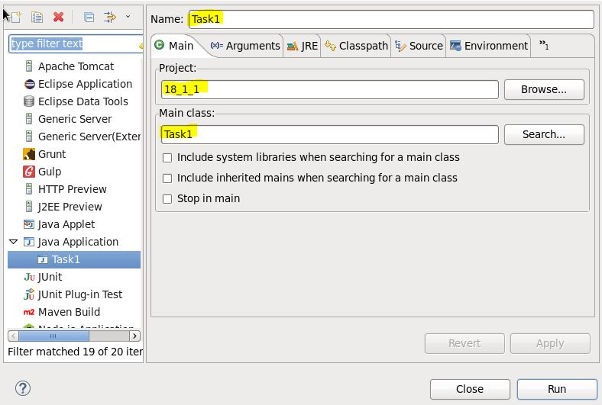

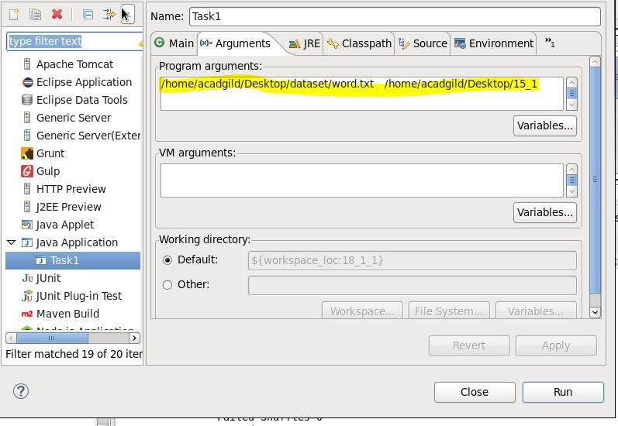

Executed Successful:

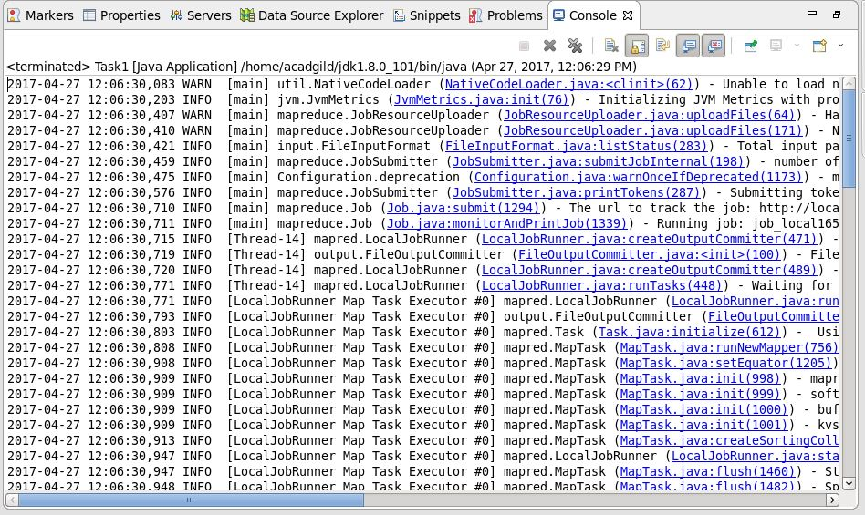

Bytes Written:

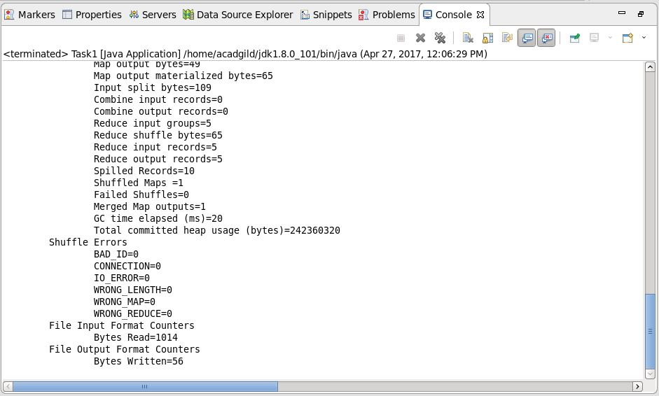

Folders created:

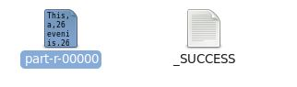

Answer:

